Flood Prediction using Machine Learning
A Data Science Project Report

1. Introduction
Floods are among the most damaging natural disasters, and early prediction can significantly reduce loss of life and property. This project builds a machine learning pipeline that predicts flood occurrence from meteorological indicators such as temperature, humidity, cloud cover, and seasonal rainfall totals.
The workflow follows the standard data science lifecycle: data loading, descriptive statistics, univariate and multivariate exploratory analysis, preprocessing, model training and comparison, and deployment through a Flask web application.

2. Libraries Used
- NumPy & Pandas — data manipulation and numerical computation
- Matplotlib & Seaborn — data visualization (distributions, boxplots, heatmaps)
- Scikit-learn — preprocessing, model training, and evaluation
- XGBoost — gradient-boosted tree model for higher predictive accuracy
- Flask — web application for serving the trained model
- Joblib — saving and loading the trained model and scaler

3. Dataset
The dataset ('flood dataset.xlsx') contains 300 records with the following columns: Temp, Humidity, Cloud Cover, ANNUAL, Jan-Feb, Mar-May, Jun-Sep, Oct-Dec, avgjune, sub, and the target variable flood (0 = no flood, 1 = flood).

3.1 Descriptive Analysis
- head() — inspected the first records to understand column layout
- shape — confirmed 300 rows and 11 columns
- info() — reviewed data types and identified a small number of missing values
- describe() — generated mean, standard deviation, and percentile statistics for every numeric feature

4. Univariate Analysis
Each numeric feature was examined individually using distribution plots and boxplots.

4.1 Distribution Plots
Distribution plots reveal that most rainfall-related features are right-skewed, reflecting the seasonal, bursty nature of monsoon rainfall, while Temperature and Humidity are closer to a normal distribution.
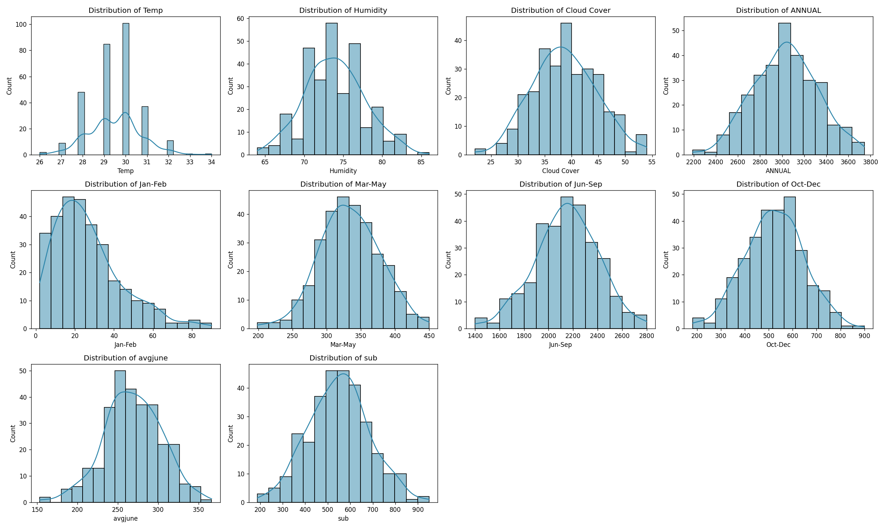
Figure 1: Distribution of numeric features

4.2 Boxplots and Outlier Detection
Boxplots were used to detect outliers in each feature. Extreme values were capped to the upper/lower IQR boundary (rather than removed) during preprocessing, preserving the sample size while limiting the influence of extreme readings on the models.
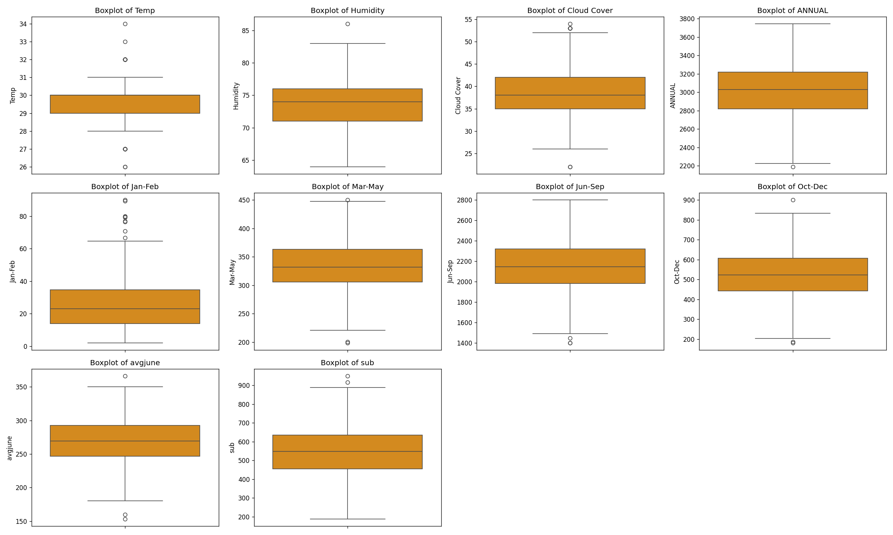
Figure 2: Boxplots showing spread and outliers

5. Multivariate Analysis
A correlation heatmap was generated to examine relationships between features and with the target variable.
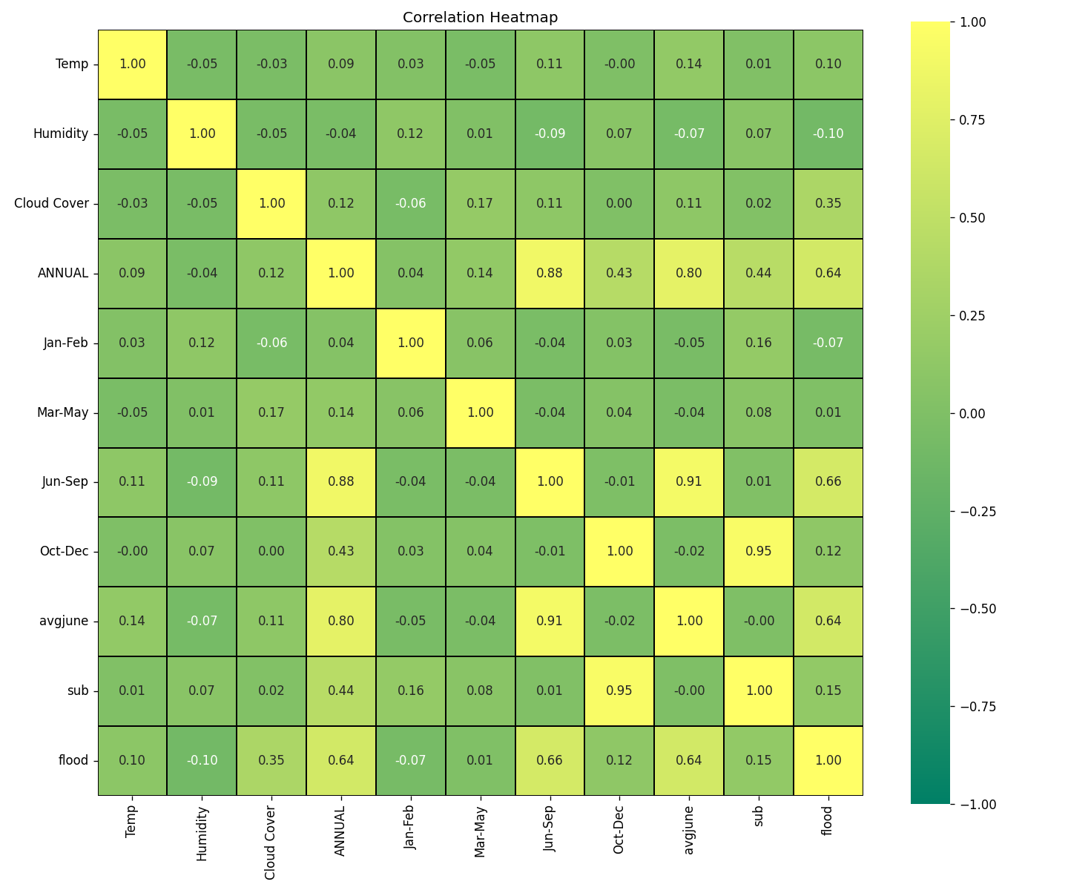
Figure 3: Correlation heatmap
Jun-Sep rainfall, ANNUAL rainfall, and avgjune show the strongest positive correlation with flood occurrence, confirming that monsoon-season rainfall volume is the primary driver of flood risk in this dataset. Oct-Dec and sub are highly correlated with each other (0.95), indicating redundant information.

6. Preprocessing
- Missing values were imputed using the column mean: dataset.fillna(dataset.mean())
- Outliers were capped using the IQR method (1.5x IQR rule)
- Features were split 80/20 into training and test sets (random_state=42)
- StandardScaler was applied for the Logistic Regression model

7. Model Training & Comparison
Three classification models were trained and compared: Logistic Regression, Random Forest, and XGBoost.
Model | Accuracy | ROC-AUC
Random Forest | 0.85 | 0.9275
Logistic Regression | 0.8333 | 0.9319
XGBoost | 0.8333 | 0.9141

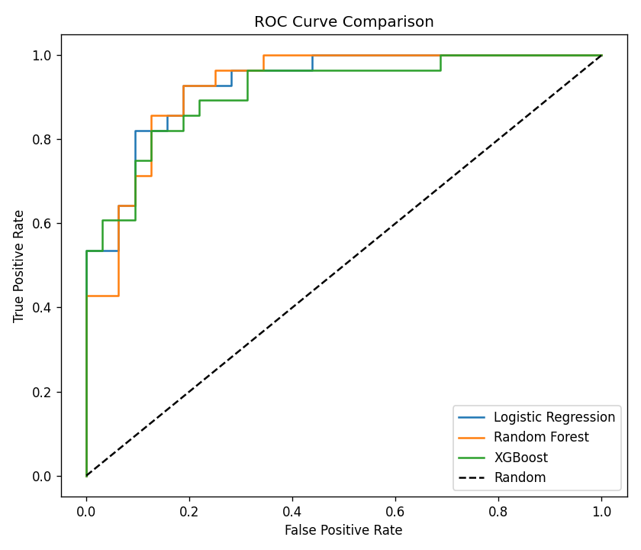
Figure 4: ROC curve comparison across models
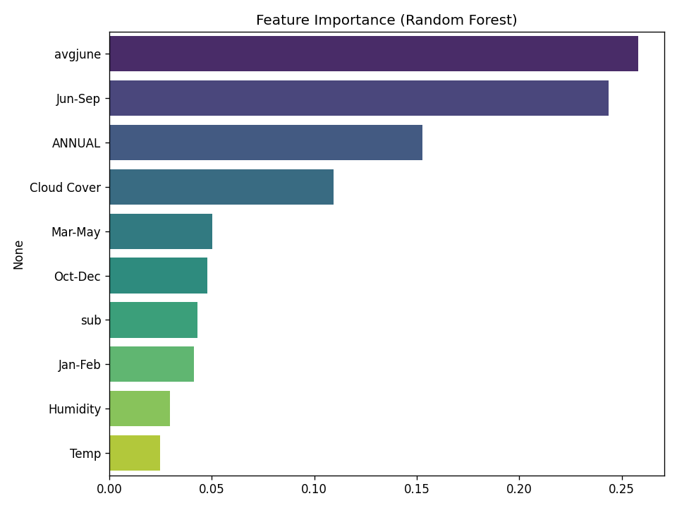
Figure 5: Feature importance from the best-performing model

8. Results
The Random Forest classifier achieved the best overall accuracy (85.0%) and was selected as the final deployed model, though all three models achieved a strong ROC-AUC above 0.91, indicating good separability between flood and non-flood conditions.
The trained model, scaler, and feature list were exported using joblib to model/flood_model.pkl, model/scaler.pkl, and model/feature_names.pkl for use in the deployment application.

9. Deployment
A lightweight Flask web application (app.py) was built to serve the trained model. Users enter meteorological readings into a form, and the app returns a flood/no-flood prediction along with the probability score. The app automatically applies feature scaling only when the loaded model requires it (e.g. Logistic Regression), making it compatible with any of the three trained models.
- Run locally with: python app.py
- Then open http://127.0.0.1:5000 in a browser

10. Conclusion
This project demonstrates a complete, reproducible machine learning workflow for flood prediction — from raw data exploration through model comparison to a working web deployment. Monsoon-season rainfall (Jun-Sep) and annual rainfall were identified as the strongest predictors of flooding, aligning with domain expectations. Future improvements could include incorporating real historical weather-station data, river discharge levels, and geographic elevation data to further improve predictive accuracy.

